Advanced Derivatives / Volatility
Beyond Black-Scholes: Smiles, Skew, and the Volatility Surface
A Level 5 module in the Quantitative Finance Curriculum
Covers: local volatility · stochastic volatility (Heston / SABR) · jump diffusion (Merton) · volatility-surface calibration · smile dynamics · volatility arbitrage · variance / volatility swaps · dispersion trading · gamma trading / delta hedging · volatility risk premia

Table of Contents
Table of Contents 1
How to Use This Guide 1
What you need to know before starting 1
Why it matters 1
How this connects to the rest of the curriculum 1
Glossary of recurring terms 1
Part 1 — Beyond Flat Volatility: Smiles and Surfaces 1
1.1 The Volatility Smile and Why Black-Scholes Fails 1
1.2 Local Volatility Models 1
1.3 Stochastic Volatility: Heston and SABR 1
1.4 Jump Diffusion: The Merton Model 1
1.5 Calibrating the Volatility Surface 1
Part 2 — Trading Volatility 1
2.1 Gamma Trading and Delta Hedging 1
2.2 Variance and Volatility Swaps 1
2.3 The Volatility Risk Premium 1
2.4 Dispersion Trading 1
Practical Exercise 1
Common Beginner Mistakes 1
Advanced Extensions 1
Professional Applications 1
Where to Go Next 1

How to Use This Guide
This document is a companion to Advanced Derivatives / Volatility, the fifth-level module in the quantitative finance curriculum. It covers the models and trading frameworks used once Black-Scholes' constant-volatility assumption is no longer good enough — which, in practice, is always: real options markets price a whole surface of implied volatilities that varies by strike and maturity, and professional volatility trading is built entirely around understanding and trading that surface.
The module is organised in two halves. Part 1 covers the models — local volatility, stochastic volatility (Heston, SABR), and jump diffusion — that were built specifically to explain the smile. Part 2 covers how volatility itself is traded as an asset: gamma trading, variance swaps, the volatility risk premium, and dispersion trading.

What you need to know before starting
- Derivatives — Core Pricing (Level 2, Depth 3+) — the Black-Scholes framework, risk-neutral pricing, the Greeks, and put-call parity, used throughout this module as the baseline every richer model is measured against.
- Stochastic Mathematics (full depth) — Itô calculus, stochastic differential equations, and the machinery to go from a model's dynamics to a pricing PDE or a simulation scheme. Heston and SABR are specified as systems of SDEs; this module assumes you can read and manipulate that notation comfortably.
- Time Series — autocorrelation, mean reversion, and volatility clustering, needed to make sense of realised-volatility dynamics and the empirical behaviour that motivates stochastic volatility models in the first place.
Tip: If Heston's two correlated SDEs or SABR's forward-and-volatility system look unfamiliar rather than merely unfamiliar-in-this-context, that is a sign to revisit stochastic mathematics before continuing — this module builds models on top of that machinery rather than re-deriving it.

Why it matters
Black-Scholes assumes a single, constant volatility for every strike and maturity of an underlying asset. Real options markets never look like this: implied volatility typically rises for deep out-of-the-money puts (the equity 'skew'), often rises again for deep out-of-the-money calls (producing a 'smile'), and the whole shape evolves with time to maturity. A trader or risk manager using flat Black-Scholes volatility is, in effect, using the wrong model for every option except the one at-the-money strike it happens to be calibrated to. Professional volatility trading — market making, dispersion, variance swaps, skew trading — is only possible with models expressive enough to capture this richer, and highly persistent, market behaviour.

How this connects to the rest of the curriculum
- Research — the volatility risk premium — the empirical, long-documented tendency for implied volatility to exceed subsequently realised volatility — is one of the most thoroughly studied statistical arbitrage effects in finance, and a natural extension of the Level 3 systematic-strategy research process applied to a derivatives context.
- Development — volatility-surface calibration engines are non-trivial numerical optimisation problems: fitting a model like SABR or Heston to dozens of simultaneously observed market quotes, robustly and fast enough to re-calibrate intraday, requires careful numerical implementation rather than a textbook formula applied once.
- Trading — this module is the direct technical foundation for a professional volatility or options trading desk. Every concept here — the smile, gamma trading, variance swaps — is standard working vocabulary on such a desk, not an advanced or optional extension of it.

Glossary of recurring terms
Implied volatility — The volatility input that, plugged into Black-Scholes, reproduces a given option's observed market price; not a forecast, but a repricing of the market's quote in volatility units.
Volatility smile / skew — The empirical pattern in which implied volatility varies systematically by strike for a fixed maturity, typically U-shaped (smile) or monotonically declining with strike (skew) in equity markets.
Volatility surface — The full two-dimensional grid of implied volatilities across both strike and time to maturity for an underlying asset.
Local volatility — A model (Dupire) in which volatility is a deterministic function of the underlying's price and time, chosen so the model exactly reproduces every quoted market price on the surface.
Stochastic volatility — A model class (e.g. Heston) in which volatility is itself a random process, correlated with the underlying's returns, rather than a deterministic function of price and time.
SABR model — A widely used stochastic volatility model, especially in interest-rate and FX markets, valued for its closed-form approximate implied-volatility formula that makes calibration fast.
Jump diffusion — A model (Merton) that adds sudden, discontinuous price jumps to the continuous Brownian motion of standard diffusion models, better capturing the fat tails and short-maturity smile that pure diffusion models struggle to reproduce.
Calibration — The process of choosing a model's parameters so that its output prices (or implied volatilities) match a set of observed market quotes as closely as possible, usually via numerical optimisation.
Delta hedging — Continuously or periodically trading the underlying asset to offset an option position's delta, isolating exposure to volatility (and other Greeks) rather than to the direction of the underlying.
Gamma trading — Profiting from the difference between an option position's implied volatility (paid or received at inception) and the volatility subsequently realised by the underlying, captured through repeated delta hedging.
Variance swap — An over-the-counter contract that pays the difference between realised variance over a period and a fixed variance strike agreed at inception, giving close to pure exposure to realised volatility with no path-dependent hedging error.
Volatility risk premium — The empirical tendency for options' implied volatility to exceed the volatility subsequently realised by the underlying, compensating volatility sellers for bearing tail risk.
Dispersion trading — A strategy that trades an index's implied volatility against the implied volatilities of its individual constituents, expressing a view on correlation rather than on volatility level alone.

Part 1 — Beyond Flat Volatility: Smiles and Surfaces
This part covers the models built specifically to explain what Black-Scholes cannot: a volatility that depends on strike and maturity, moves stochastically through time, and occasionally jumps. Each model makes a different simplifying assumption, and each is calibrated the same way — by matching a set of observed market quotes as closely as possible.

1.1 The Volatility Smile and Why Black-Scholes Fails
Black-Scholes assumes the underlying follows geometric Brownian motion with a single constant volatility, which implies every option on that underlying, at every strike and maturity, should trade at the same implied volatility. Real markets systematically violate this. Figure 1.1 shows a typical equity-index smile: implied volatility is higher for low (out-of-the-money put) strikes than for the at-the-money strike, and often ticks up again for high (out-of-the-money call) strikes.
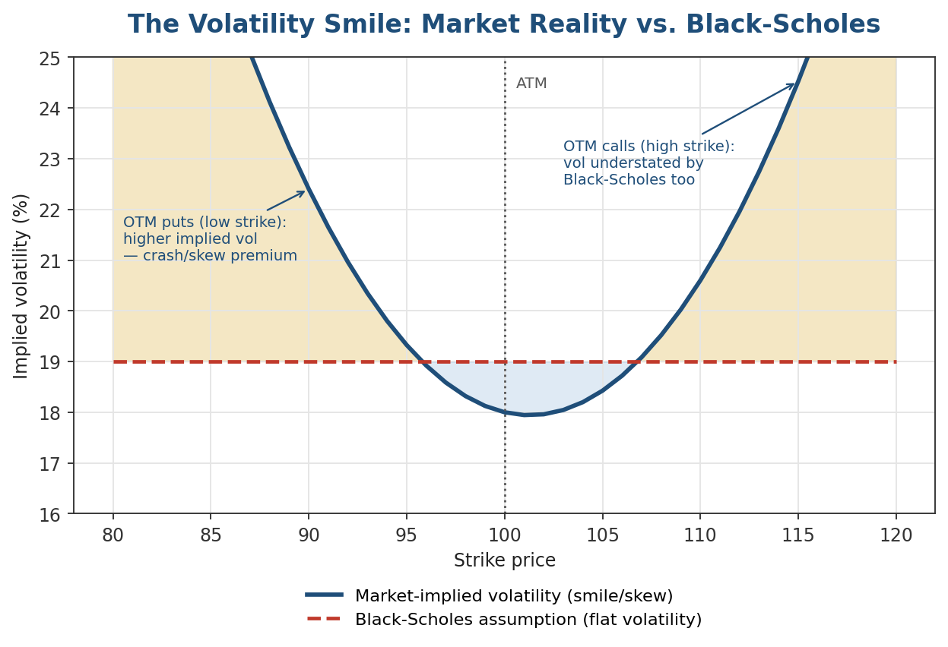
Figure 1.1 — The market's implied-volatility curve versus the single flat number Black-Scholes assumes. The gap between the two lines is exactly the mispricing an investor accepts by using flat Black-Scholes volatility.
The equity skew (higher volatility for low strikes) is usually explained by two related effects: leverage — as a stock falls, a firm's leverage rises, mechanically raising the volatility of its equity — and crash insurance demand — institutional investors persistently bid up the price (and hence implied volatility) of downside protection. Both explanations point the same direction, which is part of why the skew is so persistent rather than being competed away.
Why this distinction matters: The smile is not a market inefficiency to be arbitraged away with a better formula; it reflects real, priced risks (jumps, leverage effects, correlation) that Black-Scholes simply omits. Every model in this part exists to price options consistently with that reality, not to argue the market is wrong.

1.2 Local Volatility Models
Dupire's local volatility model keeps the underlying's dynamics as simple as possible — a single Brownian motion — but lets volatility be a deterministic function of the current price and time, σ(S, t), chosen so the model exactly reprices every quoted option on the surface:
dS_t = μ S_t dt + σ(S_t, t) S_t dW_t
Given a full, arbitrage-free implied-volatility surface, Dupire's formula recovers σ(S, t) in closed form from the surface's strike and maturity derivatives. Local volatility models are popular for exotic-option pricing precisely because they fit the entire observed surface exactly by construction — but that same property is also their key weakness.
Common mistake: Assuming local volatility is a good model of how volatility actually evolves, simply because it fits today's surface perfectly. Local volatility models are known to produce forward smiles that flatten unrealistically fast compared to observed market behaviour — they solve the static fitting problem well but describe the dynamics of the surface over time poorly, which matters for hedging path-dependent and forward-starting exotics.

1.3 Stochastic Volatility: Heston and SABR
Stochastic volatility models instead let volatility itself be a second random process, correlated with the underlying's returns — directly modelling the mechanism (volatility risk that is itself priced and time-varying) rather than backing out a function that happens to fit today's prices. The Heston model specifies two correlated square-root-type processes:
dS_t = √v_t S_t dW_t^S
dv_t = κ(θ − v_t) dt + ξ√v_t dW_t^v
corr(dW^S, dW^v) = ρ
Here v_t is the instantaneous variance, κ is the speed of mean reversion toward long-run variance θ, ξ is the volatility-of-volatility, and ρ (typically negative for equities) generates the skew: falling prices are correlated with rising volatility. Heston has a semi-closed-form solution via Fourier transform methods, which keeps calibration computationally tractable despite the added complexity.
SABR (Stochastic Alpha Beta Rho), widely used in interest-rate and FX markets, takes a related but distinct approach, modelling the forward rate and its volatility together:
dF_t = α_t F_t^β dW_t^F
dα_t = ν α_t dW_t^α
corr(dW^F, dW^α) = ρ
SABR's defining practical advantage is Hagan's closed-form asymptotic approximation for implied volatility as a function of strike, which makes calibrating it to a full smile a fast, well-behaved numerical fit rather than an expensive simulation-based search — exactly what the practical exercise in this module asks you to do.

1.4 Jump Diffusion: The Merton Model
Both local and stochastic volatility models still move the underlying continuously. Real prices sometimes jump — earnings surprises, macro announcements, flash crashes — and short-dated option smiles in particular are hard to explain without discontinuities, since continuous diffusion needs an implausibly large volatility-of-volatility to generate the same short-dated tail risk a jump does. Merton's jump-diffusion model adds a compound Poisson jump term to standard geometric Brownian motion:
dS_t / S_t = (μ − λκ) dt + σ dW_t + (J − 1) dN_t
where N_t is a Poisson process with intensity λ (the average number of jumps per year), J is the random jump size (often modelled as lognormal), and κ = E[J−1] corrects the drift so the process remains a valid pricing model. Jump diffusion is particularly good at capturing the steep short-maturity skew that pure diffusion models under-predict, at the cost of a less tractable, jump-augmented pricing PDE.

1.5 Calibrating the Volatility Surface
Every model above is only useful once fitted to observed market quotes. Calibration is a numerical optimisation: choose model parameters θ to minimise the distance between model-implied volatilities and market-quoted implied volatilities across a grid of strikes and maturities:
min_θ Σᵢ wᵢ · (σ_model(Kᵢ, Tᵢ; θ) − σ_market(Kᵢ, Tᵢ))²
Figure 1.2 shows the result of fitting SABR to a small set of market-quoted implied volatilities: the fitted curve passes close to, but rarely exactly through, every quote, and the residual at each point is itself useful diagnostic information about how well the model's functional form matches that day's market shape.
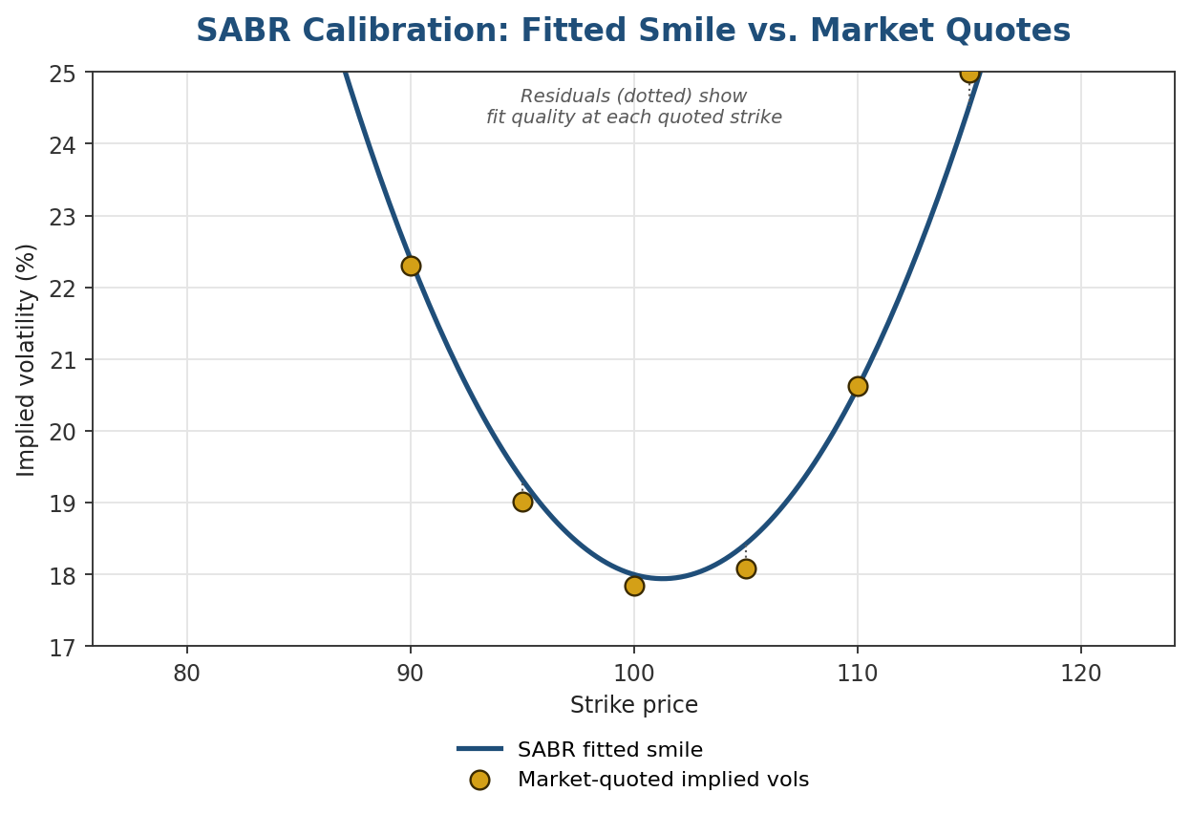
Figure 1.2 — SABR's closed-form implied-volatility approximation makes this a fast least-squares fit; the residuals at each quoted strike show where the model's assumed shape departs from the market's.
Local volatility calibration works differently in practice — rather than a parametric least-squares fit, Dupire's formula is applied directly to a smoothed, arbitrage-free interpolation of the full surface, which makes the quality of that interpolation (Section 1.2's key weakness in another guise) central to the result. Figure 1.3 shows a representative local volatility surface across both strike and maturity, illustrating the well-documented tendency for the skew to flatten as maturity lengthens.
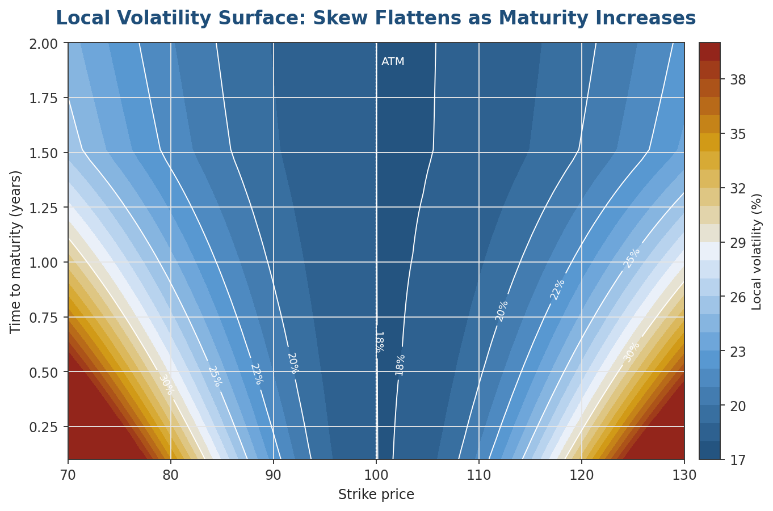
Figure 1.3 — A local volatility surface. Short-dated, far-from-the-money options show the steepest local volatility, consistent with the jump-diffusion intuition of Section 1.4.
Tip: A useful mental model for the three approaches: local volatility answers 'what deterministic function reproduces today's prices exactly', stochastic volatility answers 'what random process for volatility itself is consistent with the shape and evolution of the surface', and jump diffusion answers 'what discontinuous behaviour explains the tails a continuous process cannot'. Full stochastic-local volatility hybrids, covered in Advanced Extensions, combine all three.

Part 2 — Trading Volatility
Part 1 covered how to price options consistently with a non-flat volatility surface. This part covers how volatility itself becomes a tradable view: through delta-hedged option positions, through instruments that pay directly on realised variance, and through relative-value trades across an index and its constituents.

2.1 Gamma Trading and Delta Hedging
An option position that is continuously delta-hedged has its P&L driven almost entirely by the gap between the implied volatility paid (or received) at inception and the volatility subsequently realised by the underlying, captured through the position's gamma. A delta-hedged long option position earns a P&L, over a small time step, approximately:
dP&L ≈ ½ · Γ · S² · (σ_realised² − σ_implied²) · dt
A long option position (positive gamma) profits when realised volatility exceeds the implied volatility paid; a short option position (negative gamma) profits in the opposite case — selling volatility and collecting the difference as long as the underlying moves less than the market priced in. Figure 2.1 illustrates two short-gamma paths under different realised-volatility outcomes.
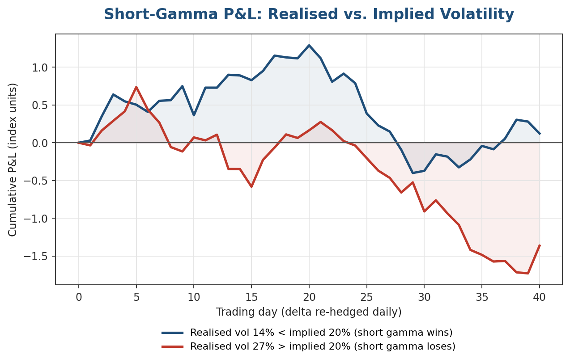
Figure 2.1 — The same short-gamma position, delta-hedged daily, produces steadily divergent P&L paths purely as a function of whether realised volatility comes in below or above the implied volatility sold at inception.
Common mistake: Treating model-implied Greeks — delta, gamma, vega — as exact, observable quantities rather than model-dependent approximations. A Black-Scholes delta and a Heston delta for the same option can differ meaningfully, especially away from the money, because each is derived from a different assumed process for how the underlying and its volatility move together. A hedge computed from the wrong model's Greeks is a systematically biased hedge, not a neutral one.

2.2 Variance and Volatility Swaps
Delta-hedged option gamma trading works, but it is path-dependent: the realised P&L depends not just on total realised volatility but on exactly when large moves occurred relative to re-hedging, and it requires continuous active management. A variance swap removes this friction by paying directly on realised variance over a fixed period, with no options or ongoing hedging required by the buyer:
payoff = notional × (σ²_realised − K_var)
where K_var is the variance strike agreed at inception (itself derived from the volatility surface, using a replicating portfolio of options across a continuum of strikes) and σ²_realised is the actual annualised variance observed over the swap's life. A volatility swap pays on realised volatility (the square root of variance) directly rather than on variance, which is more intuitive but harder to replicate and hedge, since the payoff is a non-linear (concave) function of variance.
Why this distinction matters: Because a volatility swap's payoff is concave in variance (by Jensen's inequality, E[√variance] ≤ √E[variance]), a volatility swap struck at the same expected level as a variance swap is systematically cheaper to the seller — the 'convexity adjustment' between the two is itself a standard, quotable piece of a volatility desk's pricing.

2.3 The Volatility Risk Premium
Across most asset classes and most historical periods, implied volatility has tended to exceed the volatility subsequently realised by the underlying — the volatility risk premium. Figure 2.2 shows a stylised, but qualitatively realistic, history: implied volatility (e.g. a VIX-style index) usually sits above the realised volatility that follows it, punctuated by periods (typically around volatility spikes) where the relationship reverses.
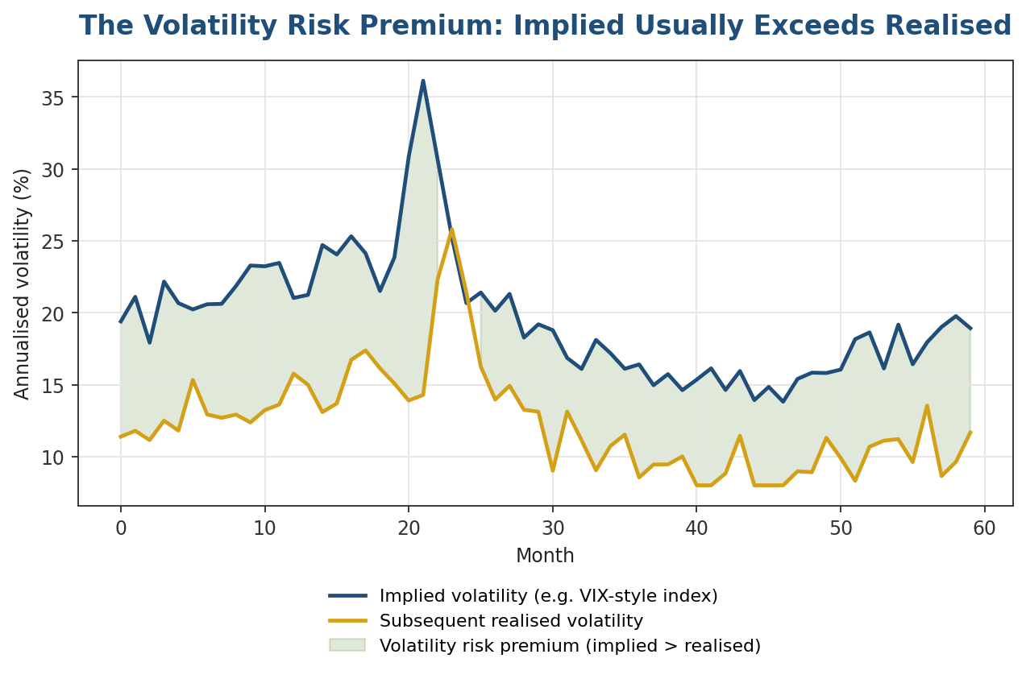
Figure 2.2 — The shaded region is the volatility risk premium: on average positive, meaning a systematic seller of volatility has collected a premium over most historical periods — in exchange for bearing occasional, sharp losses exactly when volatility spikes.
The standard explanation is that the premium compensates volatility sellers for bearing tail (crash) risk that is costly and difficult to diversify away — consistent with the leverage and crash-insurance explanations for the skew in Section 1.1. This makes the volatility risk premium a well-studied, but not risk-free, statistical arbitrage: it earns a premium in most periods and gives much of it back, occasionally all at once, in the tail events it is compensation for.

2.4 Dispersion Trading
Dispersion trading expresses a view on correlation rather than on volatility level directly, exploiting the fact that an index's implied volatility and its constituents' implied volatilities are linked through the correlation between constituent returns:
σ²_index ≈ Σᵢ wᵢ² σᵢ² + Σᵢ≠ⱼ wᵢ wⱼ ρᵢⱼ σᵢ σⱼ
If index implied volatility is 'expensive' relative to constituent implied volatilities — implying a high correlation is priced in — a dispersion trader sells index volatility and buys volatility on the individual constituents (typically weighted to be roughly vega-neutral at inception), profiting if realised correlation comes in lower than implied. This is a genuine relative-value trade: it can lose money even if every volatility forecast used to size the position turns out roughly correct, if correlation itself is the piece that moves against the position.
Trade | View expressed | Key risk
Long gamma (long options, delta-hedged) | Realised volatility will exceed implied. | Time decay (theta) if the underlying moves less than priced in.
Short variance swap | Realised volatility will fall short of the variance strike. | Sharp, potentially unbounded losses in a volatility spike.
Dispersion (short index vol, long constituent vol) | Realised correlation will be lower than implied. | Correlation can rise sharply in a broad market sell-off, exactly when the trade is most exposed.

Practical Exercise
Calibrate a SABR model to a set of market-quoted implied volatilities across strikes, and compare the fitted smile to the raw market quotes.
- Take (or construct) a set of implied volatilities quoted at a single maturity across at least 7–8 strikes spanning well below and above the money.
- Implement Hagan's SABR asymptotic implied-volatility formula as a function of strike, forward, and the four SABR parameters (α, β, ρ, ν).
- Fix β (a common convention, e.g. β = 1 for lognormal-like dynamics or β = 0.5 for a square-root-like process) and calibrate the remaining three parameters by least squares against your market quotes.
- Plot the fitted SABR smile against the raw market quotes (Figure 1.2 is a template) and compute the residual at each quoted strike.
- Refit with a different fixed β and compare: how much does the fit quality change, and how differently do the two calibrations extrapolate to strikes you did not quote?
import numpy as np
from scipy.optimize import least_squares
def sabr_implied_vol(F, K, T, alpha, beta, rho, nu):
# Hagan et al. (2002) asymptotic SABR implied volatility approximation
if abs(F - K) < 1e-8:
# ATM special case
term = ((1-beta)**2/24 * alpha**2 / F**(2-2*beta)
+ rho*beta*nu*alpha/4 / F**(1-beta) + (2-3*rho**2)*nu**2/24)
return alpha / F**(1-beta) * (1 + term*T)
logFK = np.log(F/K)
FK_beta = (F*K)**((1-beta)/2)
z = nu/alpha * FK_beta * logFK
x_z = np.log((np.sqrt(1-2*rho*z+z**2)+z-rho)/(1-rho))
term = ((1-beta)**2/24*(logFK)**2 + (1-beta)**4/1920*(logFK)**4)
return (alpha/(FK_beta*(1+term))) * (z/x_z) * (1 + T*(
(1-beta)**2/24*alpha**2/FK_beta**2
+ rho*beta*nu*alpha/4/FK_beta + (2-3*rho**2)*nu**2/24))
def residuals(params, F, K, T, market_vols, beta):
alpha, rho, nu = params
model_vols = np.array([sabr_implied_vol(F, k, T, alpha, beta, rho, nu) for k in K])
return model_vols - market_vols
result = least_squares(residuals, x0=[0.2, -0.3, 0.4],
args=(forward, strikes, maturity, market_quotes, beta_fixed),
bounds=([0.001, -0.999, 0.001], [5.0, 0.999, 5.0]))
Common mistake: Leaving β free alongside α, ρ, and ν in the optimisation. β is poorly identified from a single smile — many (β, α) combinations fit almost equally well — which is why practitioners fix β by convention or from a separate historical study, then calibrate only the remaining three parameters to each day's smile.

Common Beginner Mistakes
Mistake 1 — Using a single flat implied volatility across all strikes: Pricing or risk-managing an entire options book off one at-the-money volatility number, ignoring the well-documented smile and skew covered in Section 1.1. This misprices every option away from the money and, more dangerously, misstates the risk of any strategy (like dispersion or skew trades) whose entire thesis depends on the smile's shape.
Mistake 2 — Treating model-implied Greeks as exact rather than model-dependent: Quoting a delta or a vega as if it were an observable market fact rather than an output of whichever pricing model produced it. Two equally reasonable models calibrated to the same day's surface can disagree meaningfully on hedge ratios away from the money — a point developed further in Section 2.1.

Advanced Extensions
The natural next step beyond this module is full stochastic-local volatility (SLV) hybrid models, used at major derivatives desks precisely because pure local volatility and pure stochastic volatility each solve only half the problem. An SLV model combines a stochastic volatility process (for realistic dynamics and forward-smile behaviour) with a local volatility component (a 'leverage function') calibrated so the combined model still reprices every quoted vanilla option exactly — giving both the accurate day-one fit of local volatility and the more realistic evolution of stochastic volatility. Building and calibrating one is a substantial numerical undertaking, typically requiring particle-method or PDE-based leverage-function calibration, and is generally only justified once vanilla-consistent pricing of exotics is a genuine business requirement.

Professional Applications
- Volatility trading desks — running directional and relative-value volatility books (gamma trading, variance swaps, skew and term-structure trades) using exactly the models and hedging framework covered in this module.
- Options market making — continuously quoting two-sided markets across a full surface of strikes and maturities, which requires a calibrated, arbitrage-free surface model to price and hedge consistently in real time.
- Structured product risk management — pricing and hedging exotic and path-dependent payoffs embedded in structured products, which typically cannot be priced accurately with flat Black-Scholes volatility and require local, stochastic, or hybrid models.

Where to Go Next
This module completes the derivatives-pricing side of the curriculum's advanced track: from Black-Scholes' simplifying assumptions, through the models built to go beyond them, to the trading strategies that only make sense once the volatility surface itself is treated as the object of interest. Combined with Level 3's systematic strategies and this level's High-Frequency Trading module, it gives a broad view of the different places sophisticated trading edges come from — statistical, structural, and now volatility-specific.

Suggested paths depending on your focus
- Heading into research: focus on Section 2.3's volatility risk premium — it is one of the best-documented risk premia in finance, and a natural bridge to the systematic-strategy research process from Level 3 applied to a derivatives context.
- Heading into infrastructure/development: focus on Section 1.5's calibration problem — building a fast, robust, numerically stable calibration engine (starting with SABR, then Heston) is exactly the kind of non-trivial optimisation work described in the curriculum connections above.
- Heading into trading: focus on Part 2 in full — gamma trading, variance swaps, and dispersion are the direct working vocabulary of a professional volatility desk, and the practical exercise's SABR calibration is the minimum technical foundation expected before trading off a live surface.

